No Win No Fee
Dampness and Rot Investigations

Introduction
Our ‘No Win, No Fee’ service allows you to use our expertise to find the source of a dampness or rot problem that may have defeated others.

INSURERS REFUSED YOUR CLAIM?
Many damp and rot claims are refused on the basis that they are the result of natural, long term events – in most cases this is not true, but proving this requires experience and some simple tests.
Summary of the service
- No fees charged up front
- Free help by telephone, fax and E Mail
- Checklist provided
- Free Technical Report
- Only a successful Insurance Claim is considered a ‘Win’
- We Invoice only if you can make an Insurance Claim.
Dampness in Buildings
Free Investigation

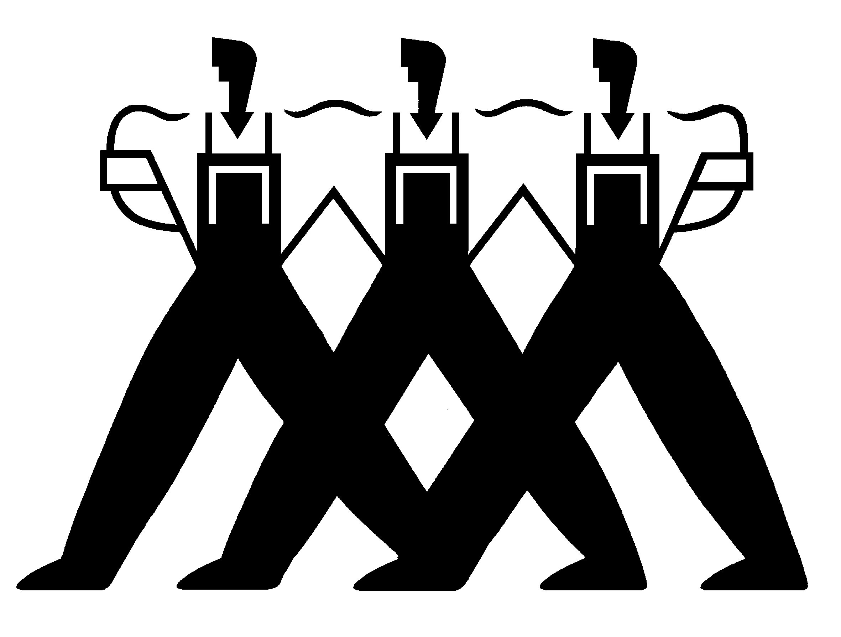
Property Repair Systems
01626 331351
DESCRIPTION

What you have to do

Supply us with the history of the problem and send some photographs by E Mail.

We will ask questions, complete an initial Checklist and then suggest various simple tests for you to carry out.

What we will do

Use our long term experience to identify the most likely causes and then ask you to carry out or arrange some simple tests.
Guide you through the process of finding the source of your problem by telephone and E Mail.
Provide all the evidence for you to submit a Claim to your Insurance Company.

Qualifications

We are Qualified Dampness and Timber Surveyors and Members of our Professional Body, the Property Care Association (PCA).

The Report we produce

Our Report will list all the steps that have been taken and the tests that you have carried out. It will present the reasons for the diagnosis and the reasons why this problem is a valid claim on your Building’s Insurance policy.

Charges

There may be some direct testing costs, (e.g. for a plumber) for testing where you might not wish to get physically involved, but we will keep these as low as possible

There are no charges for you to pay to us until we ‘WIN’. If we can find the cause of the problem, only then will we send you an Invoice, which you can pass on for reimbursement by your Insurers.

Property Repair Systems - 01626 331351
Unit 3, Olympus Business Park, TQ12 2S

DCM11/13

